 | International Journal of Research in  Language and Education  Journal Homepage: https://www.international-jrle.com | IJRLE  Vol. 1.1 · 2027

Extensive reading and incidental vocabulary growth: A quasi-experimental study of first-year EFL undergraduates
Noora Cheng ª, Jack Haddad ^{b} *
a Department of English, University of Carthage, 2070 La Marsa, Tunis, Tunisia
b Department of Applied Linguistics, University of Carthage, Tunis, Tunisia

A R T I C L E I N F O  Keywords:  Extensive reading  Incidental vocabulary  Productive vocabulary  EFL  Quasi-experimental design | A B S T R A C T  Extensive reading is widely recommended for second-language vocabulary development, yet its effect on productive vocabulary among tertiary learners remains unclear. This study examined whether a twelve-week extensive-reading programme improves the productive vocabulary of first-year English as a foreign language (EFL) undergraduates compared with intensive reading. Sixty students in two intact classes were assigned to an extensive-reading condition (n = 30) or an intensive-reading condition (n = 30) and completed a 100-item productive vocabulary test before and after the programme. Gain scores were compared using an independent-samples t test with Cohen’s d. The extensive-reading group made significantly larger gains (M = 24.6, SD = 4.1) than the intensive-reading group (M = 18.3, SD = 4.7), t(58) = 5.42, p < .001, d = 0.74. Sustained extensive reading therefore supports productive vocabulary growth and merits a larger role in EFL instruction, extending previous receptive-vocabulary findings to the productive dimension.
* Corresponding author. E-mail address: jack_haddad@example.edu
1. Introduction
Vocabulary knowledge is fundamental to second-language proficiency, underpinning reading, writing, listening, and speaking (Nation, 2013). Among the approaches proposed to build it, extensive reading—the reading of large quantities of accessible text for meaning and pleasure—has long been recommended as a source of incidental vocabulary growth (Grabe, 2009; Krashen, 1985). By exposing learners repeatedly to words in meaningful contexts, extensive reading is thought to consolidate partial word knowledge and expand the productive lexicon.
Vocabulary knowledge is fundamental to second-language proficiency, underpinning reading, writing, listening, and speaking (Nation, 2013). Among the approaches proposed to build it, extensive reading—the reading of large quantities of accessible text for meaning and pleasure—has long been recommended as a source of incidental vocabulary growth (Grabe, 2009; Krashen, 1985). By exposing learners repeatedly to words in meaningful contexts, extensive reading is thought to consolidate partial word knowledge and expand the productive lexicon.
Vocabulary knowledge is fundamental to second-language proficiency, underpinning reading, writing, listening, and speaking (Nation, 2013). Among the approaches proposed to build it, extensive reading—the reading of large quantities of accessible text for meaning and pleasure—has long been recommended as a source of incidental vocabulary growth (Grabe, 2009; Krashen, 1985). By exposing learners repeatedly to words in meaningful contexts, extensive reading is thought to consolidate partial word knowledge and expand the productive lexicon.
The evidence, however, is uneven. Whether a sustained programme of extensive reading produces measurable gains in productive vocabulary among first-year EFL undergraduates remains unclear. This study asks: To what extent does a twelve-week extensive-reading programme, compared with intensive reading, improve the productive vocabulary of first-year EFL undergraduates? It hypothesises that the extensive-reading group will achieve significantly greater gains than an intensive-reading comparison group.
(…)
2. Literature Review
Research on vocabulary acquisition through reading has grown considerably, and it is helpful to organise it around three questions: how words are learned incidentally from reading, what the empirical record shows about the size and durability of those gains, and how far the learning reaches the productive dimension that classroom instruction ultimately targets. The subsections below take each question in turn and locate the gap the present study addresses.
Across this body of work, three variables recur as moderators of success: the quantity of reading learners actually complete, the match between text difficulty and learner level, and the sensitivity of the vocabulary measure used. Studies that optimise all three tend to report the clearest gains, a finding that motivates the design choices made in the present study.
2.1. Incidental vocabulary and extensive reading
Incidental vocabulary acquisition—the learning of words as a by-product of meaning-focused activity—is central to accounts of how large lexicons are built (Webb & Nation, 2017). Reading supplies the repeated, contextualised encounters such learning requires, and extensive reading maximises that input (Grabe, 2009).
Not all encounters contribute equally, however. Research suggests that a word must be met a number of times, and in varied contexts, before it becomes available for use, and that richer processing at each encounter accelerates learning. Extensive reading supports this process precisely because its volume multiplies the opportunities for repeated, contextualised exposure.
The amount of exposure required is not trivial. Estimates suggest that a vocabulary on the order of 8,000 to 9,000 word families is needed for unassisted comprehension of authentic written text (Nation, 2006), and that individual words are typically acquired only after numerous meetings (Webb, 2007). Extensive reading is attractive precisely because its sheer volume can, in principle, supply the many encounters that deliberate study alone rarely provides (Day & Bamford, 1998).
2.2. Evidence from extensive-reading studies
Empirical studies broadly support the vocabulary benefits of extensive reading, though the size of the effect varies. In a month-long case study, Pigada and Schmitt (2006) found that some aspect of knowledge was enhanced for roughly two-thirds of the target words, with gains extending beyond meaning to spelling and grammatical behaviour. Larger programmes have likewise reported reliable receptive gains, particularly when learners read in quantity from level-appropriate texts.
The picture is more nuanced when depth and durability of knowledge are considered. Gains from single encounters are often fragile, and incidental learning tends to advance recognition more quickly than recall (Elgort, 2011). The benefits of extensive reading therefore depend not only on how much learners read but also on how the resulting knowledge is measured—a point that bears directly on the design of the present study.
2.3. The productive dimension and the present gap
Productive vocabulary has been studied far less than receptive knowledge, though it is more demanding and arguably more consequential (Schmitt, 2010). Sustained programmes with tertiary EFL learners are also rare. The present study responds to both gaps, framed by input-based accounts of acquisition (Krashen, 1985; Nation, 2013), which predict that greater comprehensible input will yield larger productive gains.
This imbalance matters because productive knowledge is what most curricula ultimately target: learners are expected not merely to recognise words but to deploy them accurately in speaking and writing. If extensive reading advances receptive knowledge but not productive use, its place in the curriculum is weaker than often assumed—hence the need for studies, such as this one, that measure the productive dimension directly.
Two further gaps remain. First, much extensive-reading research has been conducted with school-age learners or in second-language settings, leaving adult EFL undergraduates comparatively under-studied. Second, few studies have tracked productive gains across a sustained programme rather than a brief intervention. The present study addresses both by measuring productive vocabulary before and after a twelve-week programme with first-year EFL undergraduates.
Two further gaps remain. First, much extensive-reading research has been conducted with school-age learners or in second-language settings, leaving adult EFL undergraduates comparatively under-studied. Second, few studies have tracked productive gains across a sustained programme rather than a brief intervention.
(…)
3. Method
3.1. Design and participants
The study used a quantitative, quasi-experimental design with a nonequivalent pretest–posttest comparison group. Participants were 60 first-year EFL undergraduates (34 women, 26 men; ages 18–20) in two intact classes at one university, assigned at the class level to the extensive-reading (n = 30) or intensive-reading (n = 30) condition.
The two classes were taught by the same instructor and followed the same syllabus apart from the reading component, minimising differences in instruction. A baseline vocabulary test administered in the first week confirmed that the groups did not differ significantly before the intervention, supporting the comparability of the two conditions.
3.2. Instruments
Productive vocabulary was measured with a 100-item test administered before and after the programme; internal consistency was acceptable (Cronbach’s α = .84). The extensive-reading group read level-appropriate graded readers; the intensive group spent equivalent time on text-based exercises.
The graded readers used in the extensive-reading condition were selected to fall just below the learners’ independent reading level, so that comprehension remained high and unfamiliar words could often be inferred from context. The intensive-reading materials covered comparable topics but were shorter and accompanied by explicit vocabulary and comprehension exercises.
3.3. Procedure and analysis
The programme ran for twelve weeks. Gain scores (posttest minus pretest) were compared with an independent-samples t test and Cohen’s d in SPSS (Version 28); assumptions of normality and homogeneity of variance were met. The study was approved by the University Research Ethics Committee (approval no. 2026/045), and informed consent was obtained from all participants.
Before the main analysis, the assumptions underlying the t test were examined: scores were approximately normally distributed within each group, and Levene’s test indicated homogeneity of variance. Effect size was reported as Cohen’s d in order to convey the practical magnitude of any difference alongside its statistical significance.
(…)
4. Results
Both groups improved from pretest to posttest, and the extensive-reading group gained more. Descriptive statistics for both testing occasions are reported in Table 1, and the overall pattern of change is displayed in Figure 1.
At pretest the two groups were closely matched (extensive M = 42.1, SD = 5.3; intensive M = 41.8, SD = 5.1). By posttest the extensive-reading group had reached a mean of 66.7 (SD = 5.8) and the intensive-reading group a mean of 60.1 (SD = 6.0), corresponding to mean gains of 24.6 and 18.3 points respectively.
Table 1. Pretest and posttest productive vocabulary scores by group
Group | n | Pretest M (SD) | Posttest M (SD) | Gain M (SD)
Extensive reading | 30 | 42.1 (5.3) | 66.7 (5.8) | 24.6 (4.1)
Intensive reading | 30 | 41.8 (5.1) | 60.1 (6.0) | 18.3 (4.7)
Extensive reading | 30 | 42.1 (5.3) | 66.7 (5.8) | 24.6 (4.1)
Intensive reading | 30 | 41.8 (5.1) | 60.1 (6.0) | 18.3 (4.7)
Extensive reading | 30 | 42.1 (5.3) | 66.7 (5.8) | 24.6 (4.1)
Intensive reading | 30 | 41.8 (5.1) | 60.1 (6.0) | 18.3 (4.7)
Note. Scores are out of 100; SD in parentheses; Gain = posttest − pretest.
An independent-samples t test on the gain scores showed that the difference between conditions was statistically significant, t(58) = 5.42, p < .001. The associated effect size was large (Cohen’s d = 0.74), indicating that the advantage of extensive reading was substantial as well as reliable.
As Figure 1 shows, the two groups began from a similar baseline, but the posttest bars diverge, with the extensive-reading group rising more steeply. The non-overlapping pattern of the gain scores is consistent with the significant between-groups difference.
Gains within the extensive-reading group were also more uniform, as reflected in its smaller standard deviation, suggesting that most learners—rather than a few high achievers—benefited from the programme.
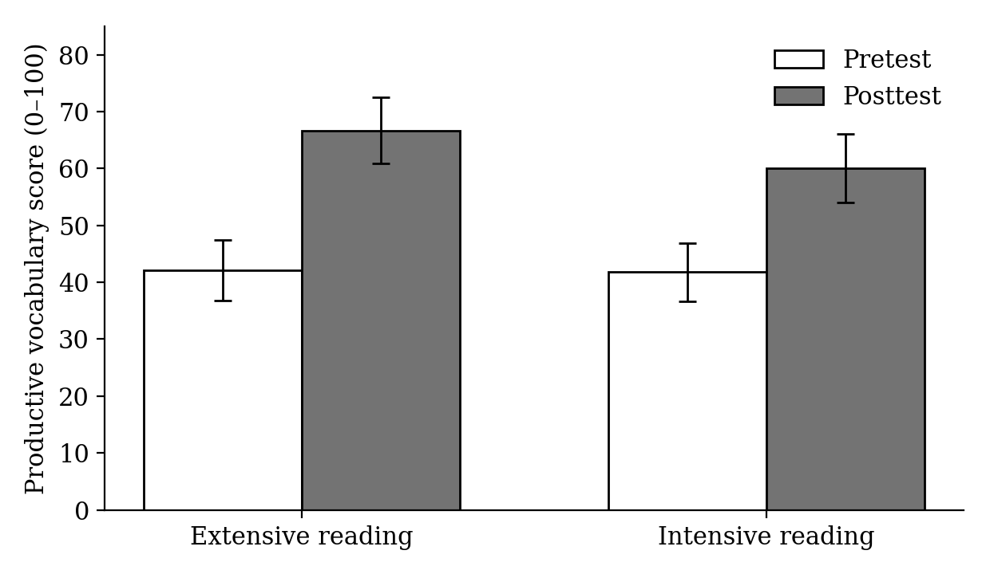
Figure 1. Mean pretest and posttest scores by group
Note. Error bars represent standard deviations.
Gains within the extensive-reading group were also more uniform, as reflected in its smaller standard deviation, suggesting that most learners—rather than a few high achievers—benefited from the programme. Gains within the extensive-reading group were also more uniform, as reflected in its smaller standard deviation, suggesting that most learners—rather than a few high achievers—benefited from the programme. Gains within the extensive-reading group were also more uniform, as reflected in its smaller standard deviation, suggesting that most learners—rather than a few high achievers—benefited from the programme.
(…)
5. Discussion
The findings support the hypothesis: sustained extensive reading produced significantly larger productive vocabulary gains than intensive reading. This is consistent with input-based accounts (Krashen, 1985) and Nation’s (2013) emphasis on repeated meaningful encounters, and it extends earlier receptive-vocabulary findings to the productive dimension. Practically, it supports giving extensive reading a larger place in tertiary EFL curricula.
These results align with input-based accounts of acquisition, which hold that comprehensible, meaning-focused exposure drives the gradual conversion of partial word knowledge into usable vocabulary (Krashen, 1985; Nation, 2013). The larger and more uniform gains of the extensive-reading group are consistent with the view that the volume of exposure, rather than intensive study of fewer words, is decisive for productive growth.
The findings also extend earlier work, much of which has focused on receptive vocabulary or school-age learners, to the productive vocabulary of university students. For teachers, the practical implication is that dedicating sustained class and independent time to level-appropriate reading can yield measurable productive gains within a single semester.
The findings also extend earlier work, much of which has focused on receptive vocabulary or school-age learners, to the productive vocabulary of university students. For teachers, the practical implication is that dedicating sustained class and independent time to level-appropriate reading can yield measurable productive gains within a single semester.
The findings also extend earlier work, much of which has focused on receptive vocabulary or school-age learners, to the productive vocabulary of university students. For teachers, the practical implication is that dedicating sustained class and independent time to level-appropriate reading can yield measurable productive gains within a single semester.
(…)
6. Conclusion
Because assignment was at the class level, the groups were nonequivalent; the study was conducted in one institution and included no delayed posttest, so the durability of the gains is unknown.
Future research could strengthen these conclusions in several ways: by assigning participants individually and at random, by adding a delayed posttest to gauge the durability of the gains, and by triangulating the productive measure with learners’ actual writing and speaking. Replication in other institutions and language backgrounds would further clarify how far the pattern generalises.
Taken together, the study offers evidence that a sustained programme of extensive reading can produce substantial gains in productive vocabulary among first-year EFL undergraduates. Read widely and consistently, the findings suggest, and the productive lexicon grows—an outcome that supports giving extensive reading a fuller place in the tertiary curriculum.
Taken together, the study offers evidence that a sustained programme of extensive reading can produce substantial gains in productive vocabulary among first-year EFL undergraduates. Read widely and consistently, the findings suggest, and the productive lexicon grows—an outcome that supports giving extensive reading a fuller place in the tertiary curriculum.
(…)
Disclosure of interest
No potential conflict of interest was reported by the author(s).
Funding
This work received no specific grant from any funding agency in the public, commercial, or not-for-profit sectors.
Declaration of generative AI use
The authors declare that no generative artificial-intelligence tools were used in the preparation of this manuscript.
Data availability statement
The data that support the findings of this study are available from the corresponding author, L.M., upon reasonable request.
Notes on contributors
Noora Cheng is an assistant professor of English at the University of Carthage. Her research focuses on second-language reading, vocabulary acquisition, and task-based learning.
Jack Haddad is a lecturer in applied linguistics at the University of Carthage. His research interests include quantitative research methods and EFL assessment.
References
Day, R. R., & Bamford, J. (1998). Extensive reading in the second language classroom. Cambridge University Press.
Elgort, I. (2011). Deliberate learning and vocabulary acquisition in a second language. Language Learning, 61(2), 367–413. https://doi.org/10.1111/j.1467-9922.2010.00613.x
Grabe, W. (2009). Reading in a second language: Moving from theory to practice. Cambridge University Press.
Krashen, S. D. (1985). The input hypothesis: Issues and implications. Longman.
Nation, I. S. P. (2006). How large a vocabulary is needed for reading and listening? The Canadian Modern Language Review, 63(1), 59–82. https://doi.org/10.3138/cmlr.63.1.59
Nation, I. S. P. (2013). Learning vocabulary in another language (2nd ed.). Cambridge University Press.
Pigada, M., & Schmitt, N. (2006). Vocabulary acquisition from extensive reading: A case study. Reading in a Foreign Language, 18(1), 1–28.
Schmitt, N. (2010). Researching vocabulary: A vocabulary research manual. Palgrave Macmillan.
Webb, S. (2007). The effects of repetition on vocabulary knowledge. Applied Linguistics, 28(1), 46–65. https://doi.org/10.1093/applin/aml048
Webb, S., & Nation, P. (2017). How vocabulary is learned. Oxford University Press.

Keep in mind the following rules:

Journal Article
Niepel, C., Hausen, J. E., Weber, A. M., & Möller, J. (2025). Understanding mean-level and intraindividual variability in state academic self-concept: The role of students’ trait expectancies and values. Journal of Educational Psychology, 117(5), 772–788. https://doi.org/10.1037/edu0000946
Book
Levenson, H., Jinich, S., Vaz, A., & Rousmaniere, T. (2025). Deliberate practice in emotionally focused couple therapy. American Psychological Association. https://doi.org/10.1037/0000436-000
Chapter in an Edited Book
Zeleke, W. A., Hughes, T. L., & Drozda, N. (2020). Home–school collaboration to promote mind–body health. In C. Maykel & M. A. Bray (Eds.), Promoting mind–body health in schools: Interventions for mental health professionals (pp. 11–26). American Psychological Association. https://doi.org/10.1037/0000157-002
Conference Session
Davidson, R. J. (2019, August 8–11). Well-being is a skill [Conference session]. APA 2019 Convention, Chicago, IL, United States.
Doctoral Dissertation
Horvath-Plyman, M. (2018). Social media and the college student journey: An examination of how social media use impacts social capital and affects college choice, access, and transition (Publication No. 10937367) [Doctoral dissertation, New York University]. ProQuest Dissertations and Theses Global.

